Design Document For Mobile Application Project 2019

Application Name : Multi App(cross platform)

Developer Name : Raja Naseer Ahmed Khan

Date : 1st February 2019

Version : Visual Studio 2017

Stakeholders : Raja Khan and Damien Costello

Table of Content.

1. Introduction.
2. Overview of App.
3. Design.
4. Systems Requirements.
5. Conclusion.

1.Introuduction:

*This App shows the Weather data through OpenWeather API by using the city name as search query. Irish News Headlines, Saves Contact Information and takes Photo/Videos, it’s Cross platform hence, can be used on any available device in market.*

2.OverView of App:

using System.Net.Http;

using System.Threading.Tasks;

using Newtonsoft.Json;

These above libraries are important for HTTP communication and Json read and transfer of data. Those can be installed through market place in visual studio 2017

1.Design Main Page:

Clock Time

**App Title**

**Irish News**

**Weather**

Contact Book

Camera

2.Design Clock:

3.Design News Page:

Welcome To Irish New

Photo

Title

Content

Photo

Title

Content

Photo

Title

Content

Photo

Title

Content

3.Design Weather Page:

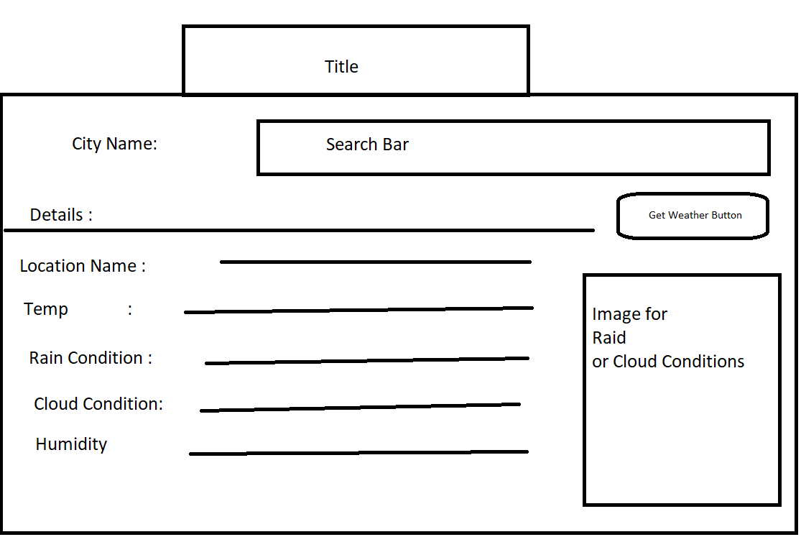

3.Design Weather Page:

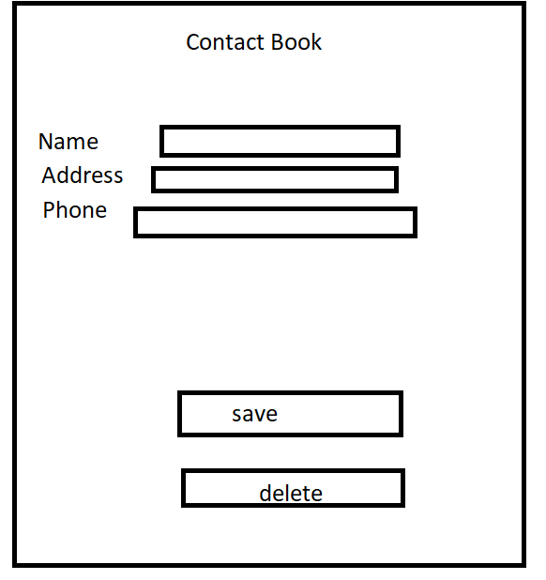

4. System Requirements:

Usage Requirements:

* Windows 10 or Above.
* Android Platform jelly bean or above.
* IOS5 or Above.
* Internet Connection.

Development Requirements:

Visual Studio 2017.

SQLite

Newtonsoft.Json Library.

Microsoft.Net.Http Libarary.

OpenWeather API Key.

5.Conclusion:

Nice Looking App for Fetching the Json Data from OpenWeather and further enhancement are done in due course, as well further functionalities in different navigations will be added.